12. ReactJS-HOL:
Create react app with the name “ticketbookingapp” & open it in the vs code.
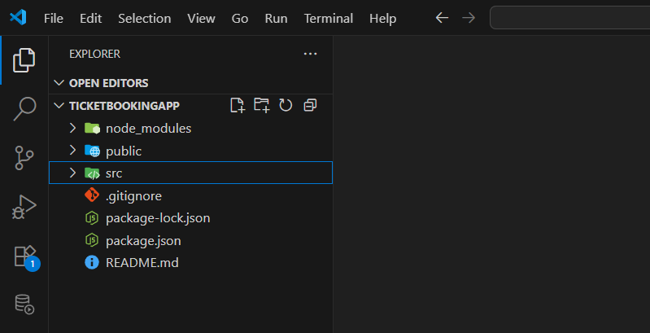
App component:
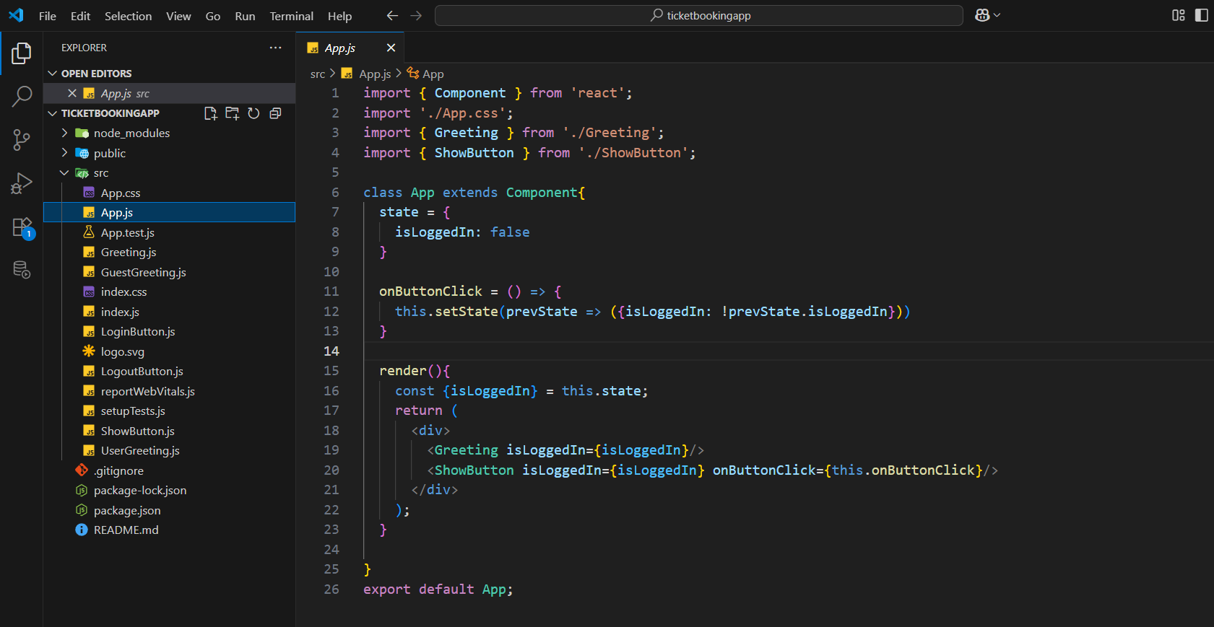
Greetings component:
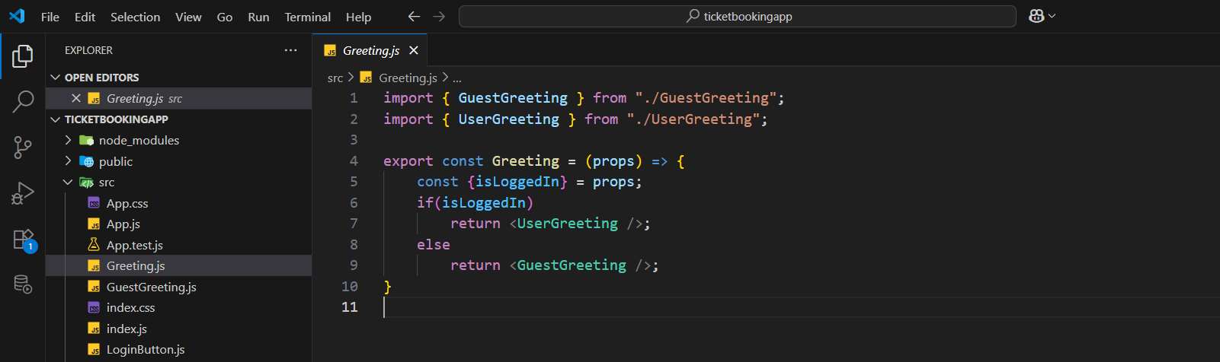
Guest Greetings component:
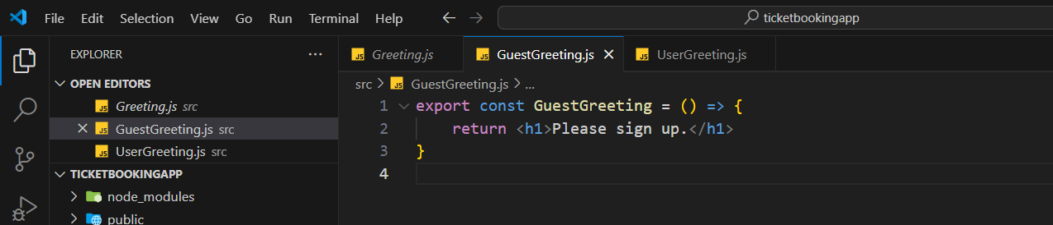
User Greetings component:
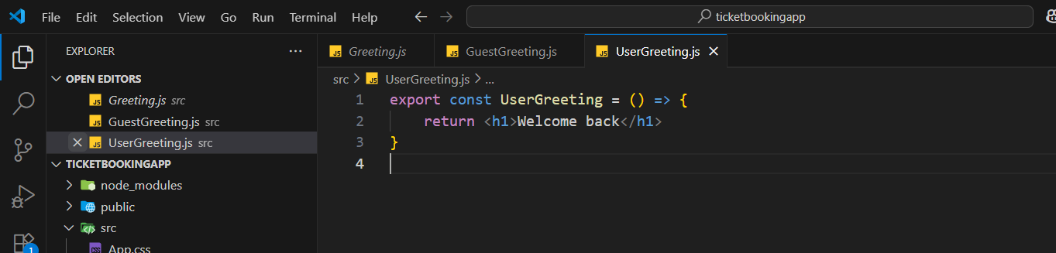
Show Button component
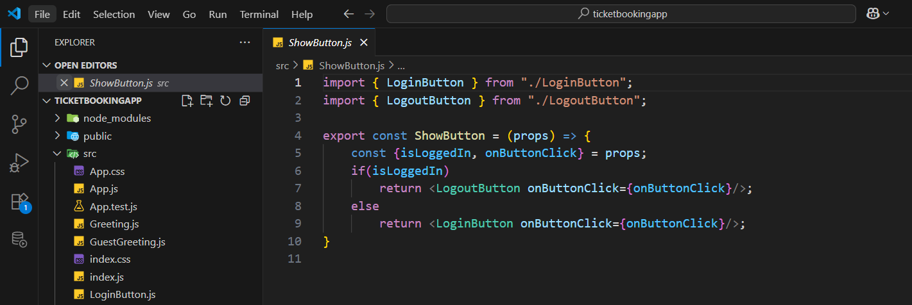
Logout Button component:
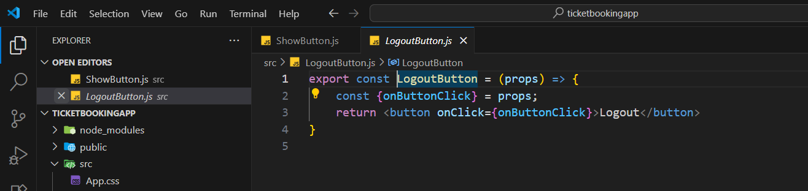
Login Button component:
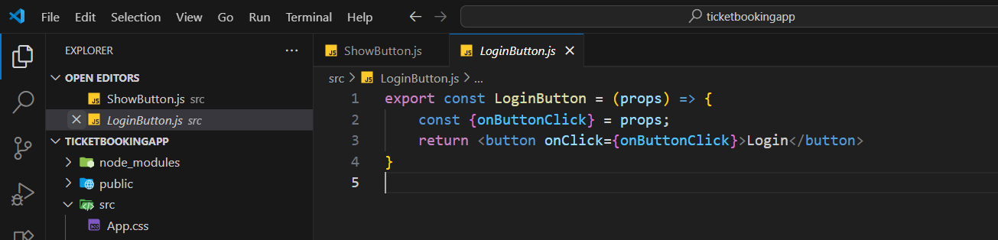

Output:
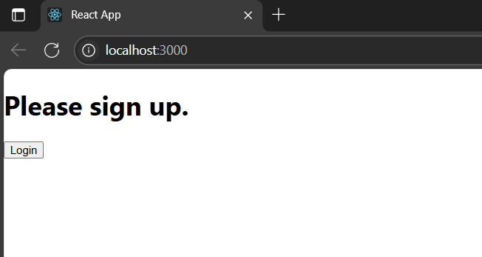
When we click on the login button we will get the below page
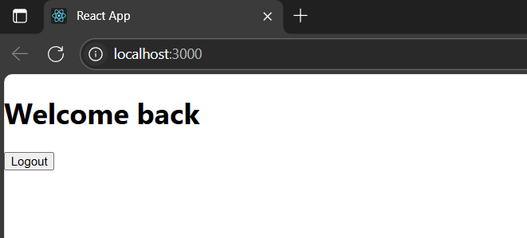
If we click the logout button we get back to the first page again.

